**WEEK 7 : REACT JS  
   
9. ReactJS-HOL**

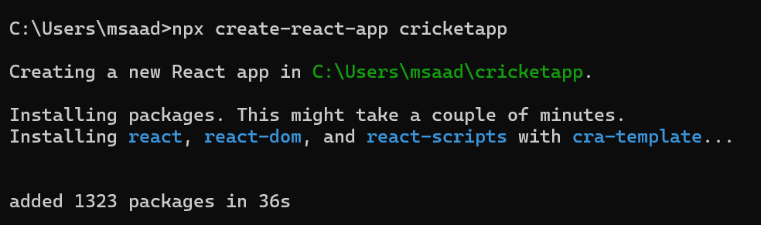

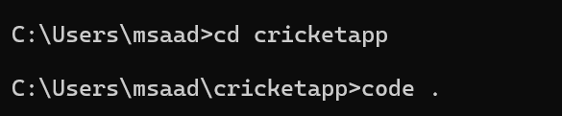

**Folder Structure:**

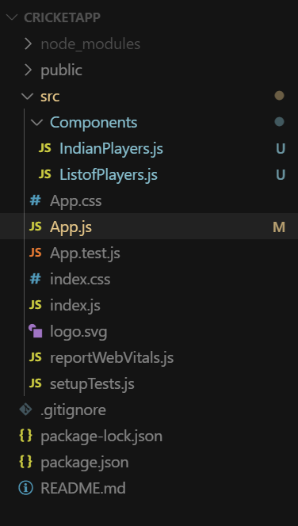

**ListofPlayers.js**

import React from 'react';

const ListofPlayers = () => {

  const players = [

    { name: "Virat Kohli", score: 100 },

    { name: "Rohit Sharma", score: 85 },

    { name: "Hardik Pandya", score: 40 },

    { name: "KL Rahul", score: 75 },

    { name: "Rishabh Pant", score: 60 },

    { name: "Shreyas Iyer", score: 90 },

    { name: "Shubman Gill", score: 50 },

    { name: "Suryakumar Yadav", score: 95 },

    { name: "Jasprit Bumrah", score: 35 },

    { name: "Mohammed Siraj", score: 70 },

    { name: "Ravindra Jadeja", score: 45 }

  ];

  const filteredPlayers = players.filter(*player* => *player*.score >= 70);

  return (

    <div>

      <h2>Players with Score ≥ 70</h2>

      <ul>

        {filteredPlayers.map((*player*, *index*) => (

          <li *key*={*index*}>{*player*.name} - {*player*.score}</li>

        ))}

      </ul>

    </div>

  );

};

export default ListofPlayers;

**IndianPlayers.js**

import React from 'react';

const IndianPlayers = () => {

  const team = ["Virat", "Rohit", "Hardik", "Pant", "Bumrah", "Iyer"];

  const [odd1, even1, odd2, even2, odd3, even3] = team;

const T20players = ["Kohli", "Surya", "Gill"];

  const RanjiTrophyPlayers = ["Sarfaraz", "Shaw", "Ishan"];

const allPlayers = [...T20players, ...RanjiTrophyPlayers];

  return (

    <div>

      <h2>Odd Team Players</h2>

      <ul>

        <li>{odd1}</li>

        <li>{odd2}</li>

        <li>{odd3}</li>

      </ul>

      <h2>Even Team Players</h2>

      <ul>

        <li>{even1}</li>

        <li>{even2}</li>

        <li>{even3}</li>

      </ul>

      <h2>All Players (Merged)</h2>

      <ul>

        {allPlayers.map((*player*, *index*) => (

          <li *key*={*index*}>{*player*}</li>

        ))}

      </ul>

    </div>

  );

};

export default IndianPlayers;

**App.js**

import React from 'react';

import ListofPlayers from './Components/ListofPlayers';

import IndianPlayers from './Components/IndianPlayers';

function App() {

  const flag = true; *// Change to false to switch view*

  return (

    <div *className*="App">

      {flag ? <ListofPlayers /> : <IndianPlayers />}

    </div>

  );

}

export default App;

**Output:**

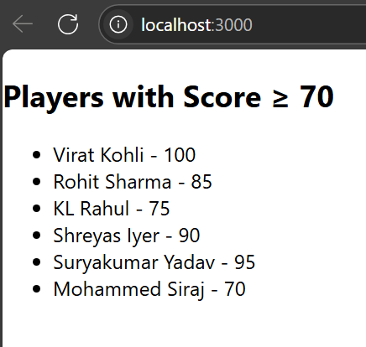

**10. ReactJS-HOL**

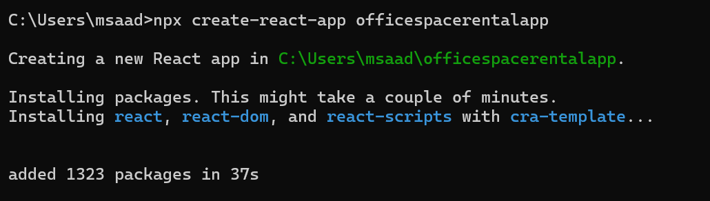

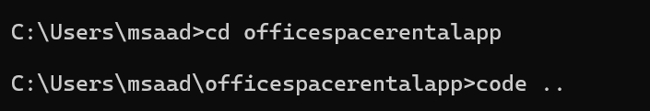

**App.js**

import React from 'react';

function App() {

*// Heading element using JSX*

  const heading = <h1>Office Space Rentals</h1>;

*// Office image URL (you can use any placeholder)*

  const imageUrl = "https://via.placeholder.com/300x150?text=Office+Space";

*// Single office object*

  const office1 = {

    name: "Indiranagar Workspace",

    rent: 55000,

    address: "1st Floor, ABC Building, Indiranagar, Bangalore"

  };

*// Array of office objects*

  const offices = [

    {

      name: "Koramangala Hub",

      rent: 45000,

      address: "2nd Floor, XYZ Towers, Koramangala, Bangalore"

    },

    {

      name: "Whitefield Corporate Park",

      rent: 75000,

      address: "Tech Park, Whitefield, Bangalore"

    },

    {

      name: "MG Road View Office",

      rent: 60000,

      address: "3rd Floor, MG Complex, Bangalore"

    }

  ];

  return (

    <div *style*={{ padding: "20px", fontFamily: "Arial" }}>

      {heading}

      {*/* Image element using JSX attribute */*}

      <img *src*={imageUrl} *alt*="Office Space" *style*={{ width: "300px", height: "150px", marginBottom: "20px" }} />

      {*/* Display single office */*}

      <h2>{office1.name}</h2>

      <p>

        <strong>Rent:</strong>{' '}

        <span *style*={{ color: office1.rent < 60000 ? "red" : "green" }}>

          ₹{office1.rent}

        </span>

      </p>

      <p><strong>Address:</strong> {office1.address}</p>

      <hr />

      {*/* Loop through office list */*}

      <h2>Available Office Spaces:</h2>

      {offices.map((*office*, *index*) => (

        <div *key*={*index*} *style*={{ border: "1px solid #ccc", padding: "10px", margin: "10px 0", borderRadius: "8px" }}>

          <h3>{*office*.name}</h3>

          <p>

            <strong>Rent:</strong>{' '}

            <span *style*={{ color: *office*.rent < 60000 ? "red" : "green" }}>

              ₹{*office*.rent}

            </span>

          </p>

          <p><strong>Address:</strong> {*office*.address}</p>

        </div>

      ))}

    </div>

  );

}

export default App;

**Output:**

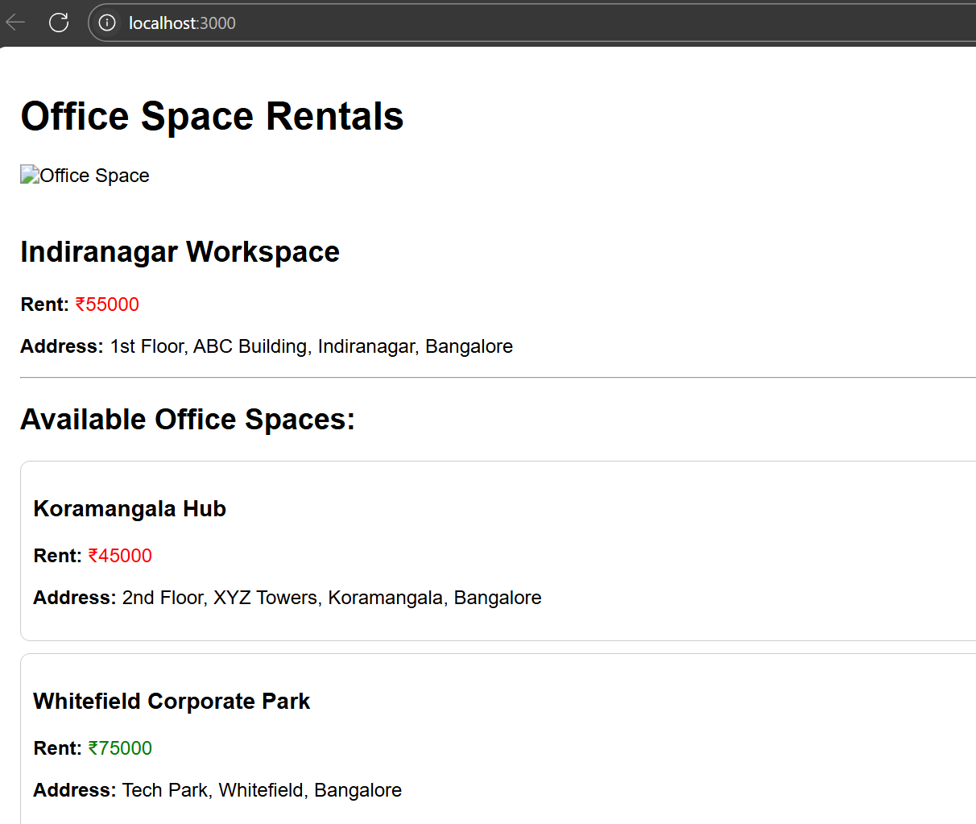

**11. ReactJS-HOL**

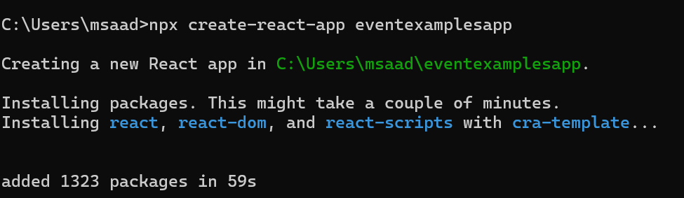

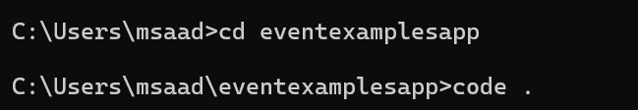

**Folder Structure:**

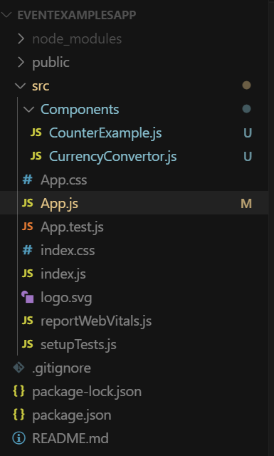

**CounterExample.js**

import React, { Component } from 'react';

class CounterExample extends Component {

  constructor(*props*) {

*super*(*props*);

    this.state = {

      count: 0

    };

  }

  increment = () => {

    this.setState({ count: this.state.count + 1 });

    this.sayHello();

  };

  decrement = () => {

    this.setState({ count: this.state.count - 1 });

  };

  sayHello = () => {

    alert("Hello! You clicked Increment.");

  };

  sayWelcome = (*msg*) => {

    alert(`Welcome Message: ${*msg*}`);

  };

  handleSyntheticEvent = (*e*) => {

*e*.preventDefault(); *// Synthetic event usage*

    alert("I was clicked (Synthetic Event)");

  };

  render() {

    return (

      <div>

        <h2>Counter: {this.state.count}</h2>

        <button *onClick*={this.increment}>Increment</button>

        <button *onClick*={this.decrement}>Decrement</button>

        <br /><br />

        <button *onClick*={() => this.sayWelcome("Welcome to the Event Example!")}>Say Welcome</button>

        <br /><br />

        <button *onClick*={this.handleSyntheticEvent}>Synthetic Click</button>

      </div>

    );

  }

}

export default CounterExample;

**CurrencyConverter.js**

import React, { Component } from 'react';

class CurrencyConvertor extends Component {

  constructor(*props*) {

*super*(*props*);

    this.state = {

      rupees: '',

      euros: ''

    };

  }

  handleChange = (*e*) => {

    this.setState({ rupees: *e*.target.value });

  };

  handleSubmit = (*e*) => {

*e*.preventDefault();

    const euroValue = (parseFloat(this.state.rupees) / 90).toFixed(2); *// Approx 1 Euro = 90 INR*

    this.setState({ euros: euroValue });

  };

  render() {

    return (

      <div>

        <h2>Currency Converter</h2>

        <form *onSubmit*={this.handleSubmit}>

          <label>Indian Rupees: </label>

          <input *type*="number" *value*={this.state.rupees} *onChange*={this.handleChange} />

          <button *type*="submit">Convert</button>

        </form>

        {this.state.euros && (

          <p>Equivalent in Euros: €{this.state.euros}</p>

        )}

      </div>

    );

  }

}

export default CurrencyConvertor;

**App.js**

import React from 'react';

import CounterExample from './Components/CounterExample';

import CurrencyConvertor from './Components/CurrencyConvertor';

function **App**() {

  return (

    <div *className*="App" *style*={{ padding: "20px" }}>

      <h1>React Event Examples</h1>

      <CounterExample />

      <hr />

      <CurrencyConvertor />

    </div>

  );

}

export default App;

**Output:**

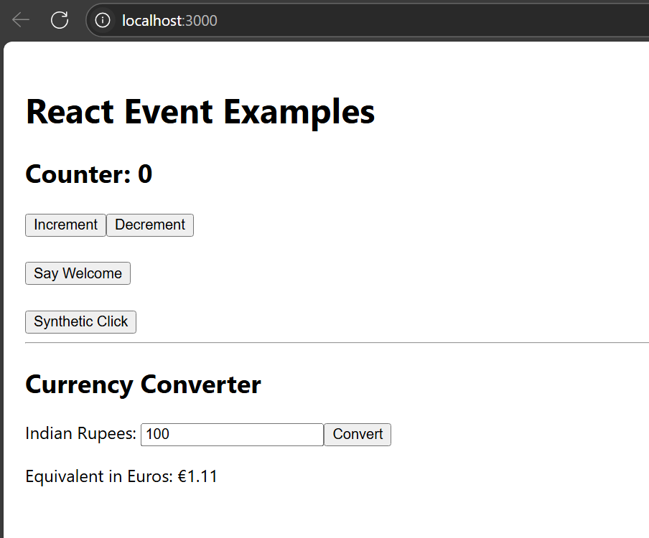

**12. ReactJS-HOL**

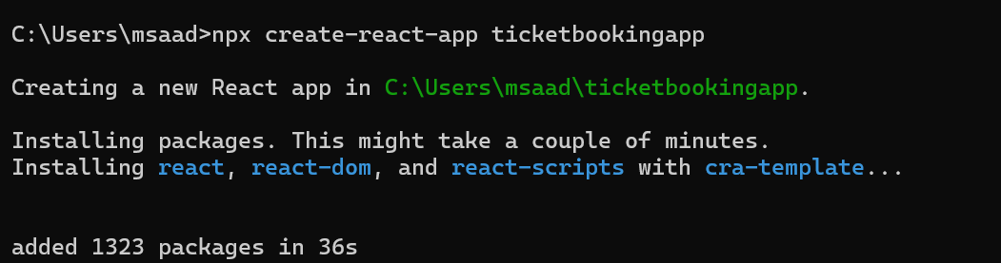

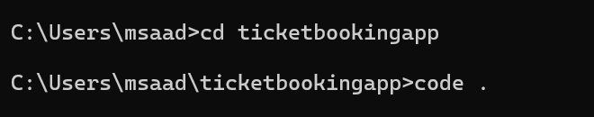

**FolderStructure**

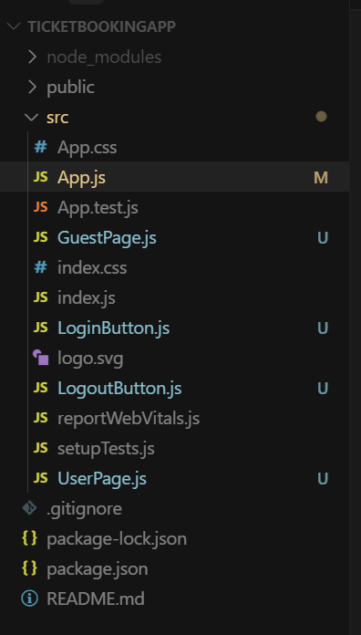

**Guestpage.js**

function GuestPage() {

    return <h2>Welcome Guest! Browse flights below.</h2>;

  }

  export default GuestPage;

**UserPage.js**

function **UserPage**() {

    return <h2>Welcome User! You can now book your tickets.</h2>;

  }

  export default UserPage;

**LoginButton.js**

function **LoginButton**({ *onClick* }) {

    return <button *onClick*={*onClick*}>Login</button>;

  }

  export default LoginButton;

**LogoutButton.js**

function LogoutButton({ *onClick* }) {

    return <button *onClick*={*onClick*}>Logout</button>;

  }

  export default LogoutButton;

**App.js**

import React, { useState } from 'react';

import GuestPage from './GuestPage';

import UserPage from './UserPage';

import LoginButton from './LoginButton';

import LogoutButton from './LogoutButton';

function App() {

  const [isLoggedIn, setIsLoggedIn] = useState(false);

  const handleLogin = () => setIsLoggedIn(true);

  const handleLogout = () => setIsLoggedIn(false);

  let content;

  let button;

  if (isLoggedIn) {

    content = <UserPage />;

    button = <LogoutButton *onClick*={handleLogout} />;

  } else {

    content = <GuestPage />;

    button = <LoginButton *onClick*={handleLogin} />;

  }

  return (

    <div>

      <h1>Flight Ticket Booking App</h1>

      {button}

      {content}

    </div>

  );

}

export default App;

**Output:**

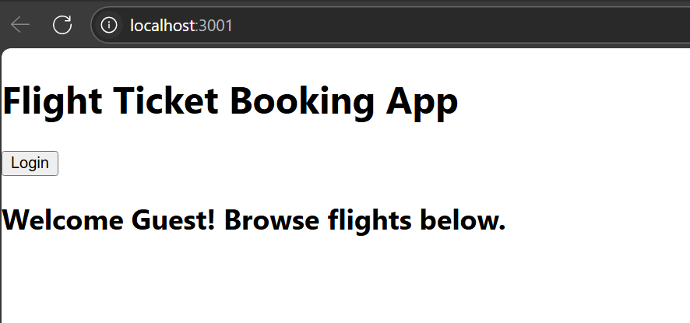

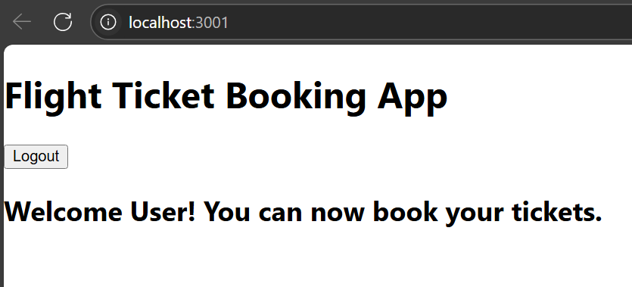

**13. ReactJS-HOL**

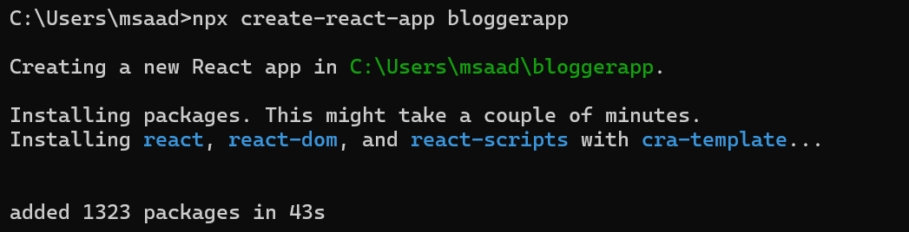

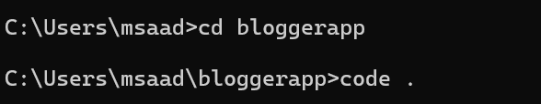

**Folder Structure:**

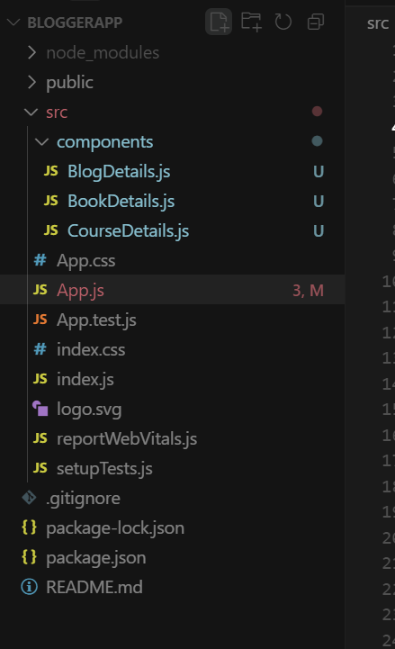

**BookDetails.js**

function BookDetails() {

    return (

      <div>

        <h2>Book Details</h2>

        <p><strong>Master React</strong></p>

        <p>670</p>

        <p><strong>Deep Dive into Angular 11</strong></p>

        <p>800</p>

        <p><strong>Mongo Essentials</strong></p>

        <p>450</p>

      </div>

    );

  }

  export default BookDetails;

**BlogDetails.js**

function **BlogDetails**() {

    return (

      <div>

        <h2>Blog Details</h2>

        <p><strong>React Learning</strong></p>

        <p><em>Stephen Biz</em></p>

        <p>Welcome to learning React!</p>

        <p><strong>Installation</strong></p>

        <p><em>Schwezdenier</em></p>

        <p>You can install React from npm.</p>

      </div>

    );

  }

  export default BlogDetails;

**CourseDetails.js**

function **CourseDetails**() {

    return (

      <div>

        <h2>Course Details</h2>

        <p><strong>Angular</strong></p>

        <p>4/5/2021</p>

        <p><strong>React</strong></p>

        <p>6/3/2020</p>

      </div>

    );

  }

  export default CourseDetails;

**App.js**

import React from 'react';

import BookDetails from './components/BookDetails';

import BlogDetails from './components/BlogDetails';

import CourseDetails from './components/CourseDetails';

function **App**() {

  return (

    <div *style*={{ padding: '20px' }}>

      <h1 *style*={{ textAlign: 'center' }}>Blogger App</h1>

      <div *style*={{ display: 'flex', justifyContent: 'space-around', marginTop: '40px' }}>

        <div *style*={{ borderRight: '3px solid green', paddingRight: '20px' }}>

          <CourseDetails />

        </div>

        <div *style*={{ borderRight: '3px solid green', paddingRight: '20px', paddingLeft: '20px' }}>

          <BookDetails />

        </div>

        <div *style*={{ paddingLeft: '20px' }}>

          <BlogDetails />

        </div>

      </div>

    </div>

  );

}

export default App;

**Output:**

